API document: System have two main objects: Client and server:

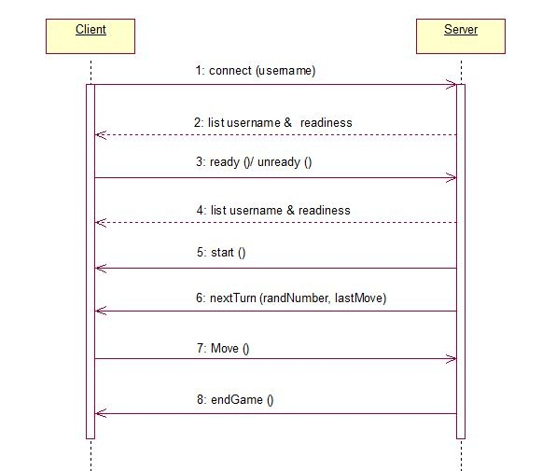

1. Public member function:

* (1) connect(Username)

Connect to server and register Username

* (3) ready()/unready()

send each User’s state for server

* (5) start()

Server send ready state for all user and start game

* (6) nextTurn(lastMove[], randNumber)

In the first turn, server send randNumber and lastMove = null for all user.

The next turns, server send last move of each user for other users and randNumber for all user.

* (7) move(x, y)

then, client send x, y location to server

* (8) endGame()

this finish state game.